**MARWARI COLLEGE, RANCHI**



**A PROJECT REPORT**

**ON**

**“TUITION MANAGEMENT SYSTEM(Tuitionwala.com)”**

Submitted in Partial Fulfilment for the Degree of

B.Sc. Information Technology

Submitted by:-

Name- AVINASH KUMAR VERMA

Exam Roll No- 14MCRBS62011

Class Roll No-61

**MARWARI COLLEGE, RANCHI**



CERTIFICATE

This is to certify that the project report entitled TUITION MANAGEMENT SYSTEM(Tuitionwala.com)

Submitted to Marwari College, Ranchi in partial fulfilment of the requirement for the award of degree of B.Sc. Information Technology, is an original work carried out by AVINASH KUMAR VERMA

SIGNATURE

(Guide) (External Examiner)

**1. INTRODUCTION**

**“TUITION MANAGEMENT SYSTEM**” is a web-based project which is made for the students and for those who want to earn money by teaching.Tuitionwala is a platform from where a student can find tuition easily.Tuitionwala is also helpful for the parents who need a tutor for their children.Students need to register themselves first in the tuitionwala,providing necessary details that help parents to find a suitable tutor for their ward.After registration stay in touch with us and keep patience.Now the parents look tutors list and find a suitable tutor.After finding a tutor parent will leave a message with their details.Now we with the details provided will notify the student and he/she will get tution.This is fast and effective way to find tuition.

In today’s life education is very important for us.Education is the need of everyone.It is the means through which we can achieve our goal and become a successful person.But it is true that for better eduaction one’s need to migrate from their place.In new place they have to manage their all expenses.Then only one option left with student that to earn money from tuition.So after that they look for tuition but due to lesser contact they are unable to find it.

**OBJECTIVE**

.

In today’s life education is very important for us.Education is the need of everyone.It is the means through which we can achieve our goal and become a successful person.But it is true that for better eduaction one’s need to migrate from their place.In new place they have to manage their all expenses.Then only one option left with student that to earn money from tuition.So after that they look for tuition but due to lesser contact they are unable to find it.

Tuitionwala is a platform from where a student can find tuition easily.Tuitionwala is also helpful for the parents who need a tutor for their children.Students need to register themselves first in the tuitionwala,providing necessary details that help parents to find a suitable tutor for their ward.After registration stay in touch with us and keep patience.Now the parents look tutors list and find a suitable tutor.After finding a tutor parent will leave a message with their details.Now we with the details provided will notify the student and he/she will get tution.This is fast and effective way to find tuition.

**LIFE CYCLE MODEL**

Feasibility Study

Requirement Analysis And  
Specification

Design

Coding And Unit Testing

Integration And System Testing

Maintenance

**SYSTEM ANALYSIS**

System analysis is the process of gathering and interpreting facts, diagnosing problems and using the information to recommend improvements on the system. System analysis is a problem solving activity that requires intensive communication between the system users and system developers.

System analysis or study is an important phase of any system development process. The system is viewed as a whole, the inputs are identified and the system is subjected to close study to identify the problem areas. The solutions are given as a proposal. The proposal is reviewed on user request and suitable changes are made. This loop ends as soon as the user is satisfied with the proposal.

**FEASIBILITY STUDY**

**WHAT IS FEASIBILITY STUDY?**

The feasibility study involves the analysis of the problem and collection of all relevant information relating to the product such as the different data items which would be input to the system, the processing required to be carried out on these data, the output data required to be produced by the system, as well as various constraints on the behavior of the system

**TYPE OF FEASIBILITY STUDY**

* Technical Feasibility
* Economic Feasibility
* Operational Feasibility

**TECHNICAL FEASIBILITY**

In the feasibility study first step is that the organization or company has to decide that what technologies are suitable to develop by considering existing system. Here in this application used the technologies like PHP, HTML, JAVA SCRIPT,CSSandMySQL

**ECONOMICAL FEASIBILITY**

#### It refers to the benefits or outcomes we are deriving from the product as compared to the total cost we are spending for developing the product. If the benefits are more or less the same asthe older system, then it is not feasible to develop the product. In the present system, the development of new product greatly enhances the accuracy of the system and cuts short the delay in the processing of Birth and Death application. The errors can be greatly reduced and at the same time provides a great level of security. Here we don’t need any additional equipment except memory of required capacity. No need for spending money on client for maintenance because the database used is web enabled database.

**OPERATIONAL FEASIBILITY**

Not only must an application make economic and technical sense, it must also make operational sense; Very often we need to improve the existing operations, maintenance, and support infrastructure to support the operation of the new application that you intend to develop.  To determine what is the impact we will need to understand both the current operations and support infrastructure of our organization and the operations and support characteristics of our new application

**4. REQUIREMENT ANALYSIS AND SPECIFICATION**

**SOFTWARE AND HARDWARE REQUIREMENT OF THE PROJECT**

#### Hardware Requirements:

System Type : INTEL

Processor : PENTIUM

Processor Speed : 2.8 GHZ

Hard Disk : 40 GB

RAM Size : 4 GB

#### Software Requirements:

Platform : Independent

Front-end : PHP,HTML, JAVA SCRIPT, CSS

Back-end : MY SQL.

**REQUIREMENT ANALYSIS AND SPECIFICATION**

Requirement analysis in systems engineering and software engineering, encompasses those tasks that go into determining the needs or conditions to meet for a new or altered product or project, taking account of the possibly conflicting requirements of the various stakeholders, analyzing, documenting, validating and managing software or system requirements.

Requirement analysis is critical to the failure of systems or software projects. The requirements should be documented, actionable, measurable, testable, traceable, related to identified business needs or opportunities and define to a level of detail sufficient for system design.

Requirements specification is the invention and definition of the behavior of a new system such that it will produce the required effects in the problem domain. It generally involves modeling. It results in the specification document.

**TESTING**

Testing is a process of executing a program with a intent of finding an error. A good test case is one that has a high probability of finding an error that is yet undiscovered. A successful test is one that uncovers a yet undiscovered error. Testing cannot show the absence of defects, it can only show software defects that are present.

**TEST CASE DESIGN**

White box Testing:

White box testing is a test case design method that uses the control structure of the procedural design to derive test cases. Using white box testing method, the software engineer can derive test cases that guarantee that all independent parts within a module have been exercised atleast once, exercise all logical decisions on their true and false sides, execute all loops at their boundaries and within their operational bounds and exercise internal data structures to ensure their validity.

Black box testing:

Black box testing method focus on functional requirements of the software. That is , black box testing enables the software engineer to derive sets of input condition that will fully exercise all functional requirements for a program.

Black box testing attempts to find errors in the following categories:

1.Incorrect or missing functions

2.Interface errors and performance errors

3.Errors in data structures or external database access.

4.Performance errors

5.Initialization and termination errors.

**TESING STRATEGIES**

A software strategy for software testing integrates software test case design techniques into a well-planned series of steps that result in successful construction of software.

There are four types of strategies:

Unit test**:**

Unit testing focuses on verification effort on the smallest unit of software design module.

The test is always white box oriented, and the step can be conducted in parallel for multiple modules.This testing is carried out during coding stage.

Integration test:

Integration testing is a systematic technique for construction of program structure while the time of conducting tests to uncover errors associated with interfacing. The objective is to take unit-tested modules and build a program structure that has been dictated by the design

Validation test**:**

Validation testing is a final series of software testing. Validation testing succeeds when the software function in a manner that can be reasonably expected by the customer. Software validation is achieved through aseries of black box tests that demonstrate conformity with requirements.

System test:

After integration of all modules of the system it will give appropriate information , expected to the user.

**MAINTENANCE**

Software maintenance in software engineering is the modification of a software product after delivery to correct faults, to improve performance or other attributes.

A common perception of maintenance is that it merely involves fixing defects. However, one study indicated that over 80% of maintenance effort is used for non-corrective actions.

This perception of maintenance is perpetuated by users submitting problem reports that in reality are functionality enhancements to the system. More recent studies put the bug-fixing proportion closer to 21%.

**SYSTEM DESIGNS**

System design is the solution for the creation of a new system. This phase focuses on the detailed implementation of the feasible system. It emphasis on translating design. Specifications to performance specification. System design has two phases of development

* Logical design
* Physical design

During logical design phase the analyst describes inputs (sources), output s(destinations), databases (data sores) and procedures (data flows) all in a format that meets the user requirements. The analyst also specifies the needs of the user at a level that virtually determines the information flow in and out of the system and the data resources. Here the logical design is done through data flow diagrams and database design. The physical design is followed by physical design or coding. Physical design produces the working system by defining the design specifications, which specify

exactly what the candidate system must do. The programmers write the necessary programs that accept input from the user, perform necessary processing on accepted data and produce the required report on a hard copy or display it on the screen.

**INPUT AND OUTPUT DESIGN**

INPUT DESIGN:

Input design is the link that ties the information system into the world of its users. The input design involves determining the inputs, validating thedata, minimizing the data entry and provides amulti-user facility.Inaccurate inputs are the most common cause of errors in dataprocessing. Errors entered by the data entry operators can be controlled by input design. The user-originated inputs are converted to a computer based format in the input design. Input data are collected and organized into groups of similar data. Once identified, the appropriate input media are selected for processing. All the input data are validated and if any data violates any conditions, the user is warned by a message. If the data satisfies all the conditions, it is transferred to the appropriate tables in the database. In this project the student details are to be entered at the time of registration. A page is designed for this purpose which is user friendly and easy to use. The design is done such that users get appropriate messages when exceptions occur.

OUTPUT DESIGN:

Computer output is the most important and direct source of information to the user. Output design is a very important phase since the output needs to be in an efficient manner. Efficient and intelligible output design improves the system relationship with the user and helps in decision making. Allowing the user to view the sample screen is important because the user is the ultimate judge of the quality of output. The output module of this system is the selected notifications.

**DATABASE**

DATABASE DESIGN:

Databases are the storehouses of data used in the software systems. The data is stored in tables inside the database. Several tables arecreated for the manipulation of the data for the system. Two essential settings for a database are

* Primary Key-the field that is unique for all the record occurrences.
* Foreign Key- the field used to set relation between tables.

Normalization is a technique to avoid redundancy in the tables.

**SYSTEM TOOLS**

The various system tools that have been used in developing both the front end and the back end of the project are being discussed in this chapter.

FRONT END:

HTML, CSS, JAVA SCRIPT, PHP

HTML (Hyper Text Markup Language):

HTML is a syntax used to format a text document on the web.

CSS (Cascading Style Sheets):

CSS is a style sheet language used for describing the look and formatting of a document written in a markup language.

Java Script:

JS is a dynamic computer programming language. It is most commonly used as part of web browsers, whose implementations allow client-sidescripts to interact with the user, control the browser, communicate asynchronously, and alter the document content that is displayed. Java Script is used to create pop-up windows displaying different alerts inthe system like “User registered successfully”,”Product added to cart” etc.

PHP(Hypertext Preprocessor):

PHP is a server-side scripting language designed for web development but also used as a general-purpose programming language. As of January 2013, PHP was installed on more than 240 million websites (39% of those sampled) and 2.1 million web servers. Originally created by Rasmus Lerdorf in 1994, the reference implementation of PHP (powered by the Zend Engine) is now produced by The PHP Group. While PHP originally stood for Personal Home Page, it now stands for PHP: Hypertext Preprocessor, which is a recursive backronym.PHP code can be simply mixed with HTML code, or it can be used in combination with various templating engines and web frameworks.

BACK END:

The back end is implemented using MySQL which is used to design the databases.

MySQL:

MySQL is the world's second most widely used open-source relational database management system (RDBMS). The SQL phrase stands for Structured Query Language.

An application software called Navicat was used to design the tables in MySQL.

**DATA FLOW DIAGRAM**

A Data Flow Diagram (DFD) is a structured analysis and design tool that can be used for flowcharting. A DFD is a network that describes the flow of data and the processes that change or transform the data throughout a system. This network is constructed by using a set of symbols that do not imply any physical implementation. It has the purpose of clarifying systemrequirements and identifying major transformations. So it is the starting point of the design phase that functionally decomposes the requirements specifications down to the lowest level of detail. DFD can be considered to an abstraction of the logic of an information-oriented or a process-oriented system flow-chart. For these reasons DFD’s are often referred to as logical data flow diagrams.

**WHAT IS A DATA DICTIONARY?**

A data dictionary, or metadata [repository](http://en.wikipedia.org/wiki/Software_repository), is a "centralized repository of information about data such as meaning, relationships to other data, origin, usage, and format." The term may have one of several closely related meanings pertaining to [databases](http://en.wikipedia.org/wiki/Database) and [database management systems](http://en.wikipedia.org/wiki/Database_management_system) (DBMS):

* a [document](http://en.wikipedia.org/wiki/Document) describing a database or collection of databases.
* an integral [component](http://en.wikipedia.org/wiki/Software_component) of a [DBMS](http://en.wikipedia.org/wiki/Database_management_system) that is required to determine its structure.
* a piece of [middleware](http://en.wikipedia.org/wiki/Middleware) that extends or supplants the native data dictionary of a DBMS.

EXTERNAL ENTITY:

An external entity is a source or destination of a data flow. Only those entities which originate or receive data are represented on a data flow diagram. The symbol used is a rectangular box.

PROCESS:

A process shows a transformation or manipulation of data flow within the system. The symbol used is an oval shape.

DATAFLOW:

The data flow shows the flow of information from a source to its destination. Data flow is represented by a line, with arrowheads showing the direction of flow. Information always flows to or from a process and may be written, verbal or electronic. Each data flow may be referenced by the processes or data stores at its head and tail, or by a description of its contents.

DATA STORE:

A data store is a holding place for information within the system: It is represented by an open ended narrow rectangle. Data stores may be long-term files such as sales ledgers, or may be short-term accumulations: for example batches of documents that are waiting to be processed. Each data store should be given a reference followed by an arbitrary number.

System Context Diagrams are  diagrams used in  systems design  to represent the more important external factors that interact with the system at hand. This type of diagram usually pictures the system at the centre, with no details of its interior structure, surrounded by all its interacting systems, environment and activities. The objective of a system context diagram is to focus attention on external factors and events that should be considered in developing a complete set of system requirements and constraints”.

**CONTEXT DIAGRAM** DIAGRAM

System context diagrams are related to  UML, and show the interactions between a system and other actors with which the system is designed tointerface.Context diagrams can be developed with the use of two types of building blocks:

**DFD LEVEL 0**

**Register,Login, Manage Account,See notification**

**See tutors list, Select tutor, Leave Message**

E:\Project\TuitionWala\images\avi123.jpg

**Manage flow of information, Notifystudent, Feedback response**

**DFD LEVEL 1**

Exit if Invalid

Valid

Checking login

E:\Project\TuitionWala\images\avi123.jpg

Database

Database(Student profile Details) Database(Message )

**WHAT ARE E-R DIAGRAMS?**

In  software engineering an  entity-relationship model (ERM) is an abstract and conceptual representation of  data. Entity-relationship modeling is a  database modeling method, used to produce a typeof  conceptual schema or  semantic data model of a system, often a relational, and its requirements in a  top-down fashion. Diagrams created by this process are called  entity-relationship diagrams, ER diagrams, or  ERDs.

Address Qualification Teaching Exper. Preffered Board

Father’s name Mobile no.

Sex E-mail Id

DOB Password

Name Confirm Password

E:\Project\TuitionWala\images\avi123.jpg

**Notify User about request for tuition**

**Message Name,Address,Contact no.,Tuition for class**

**TABLES**

* User Signup Table

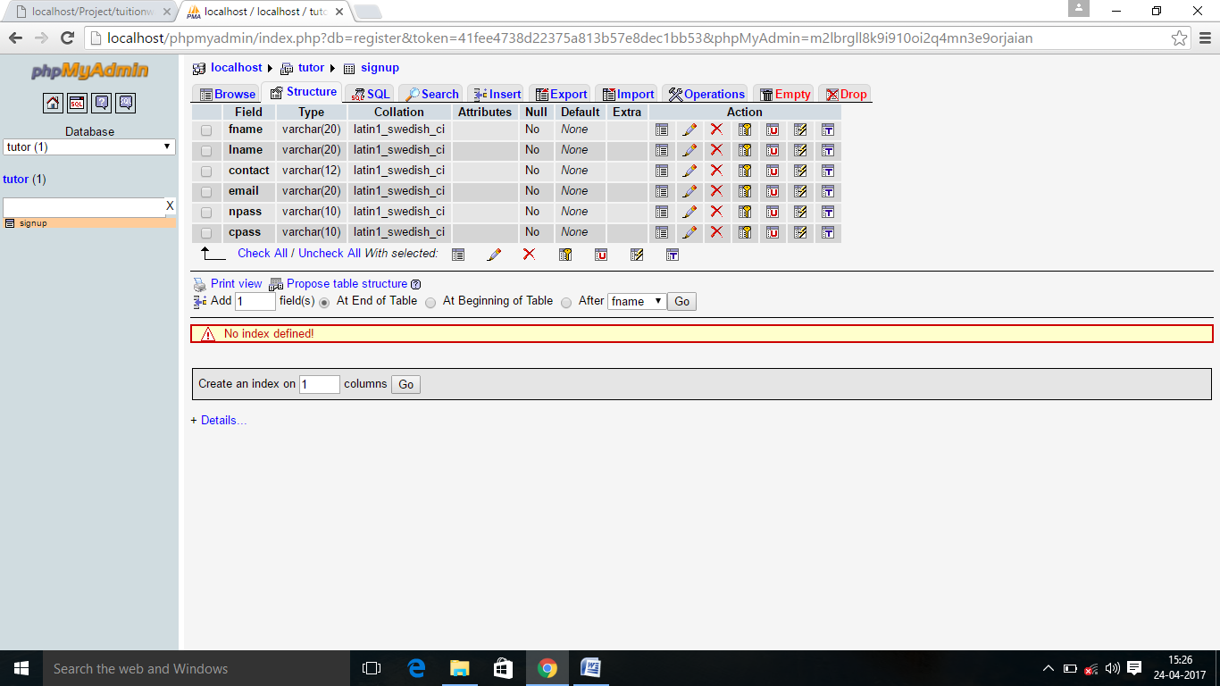

* Regsitration Table

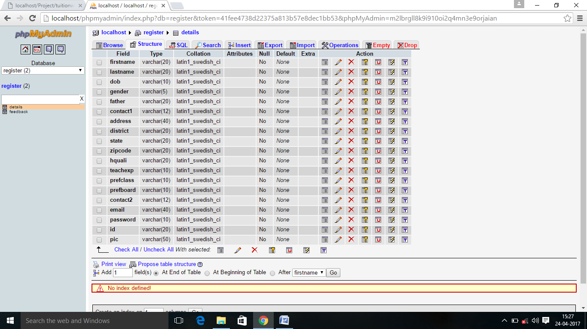

* Client Feedback Table

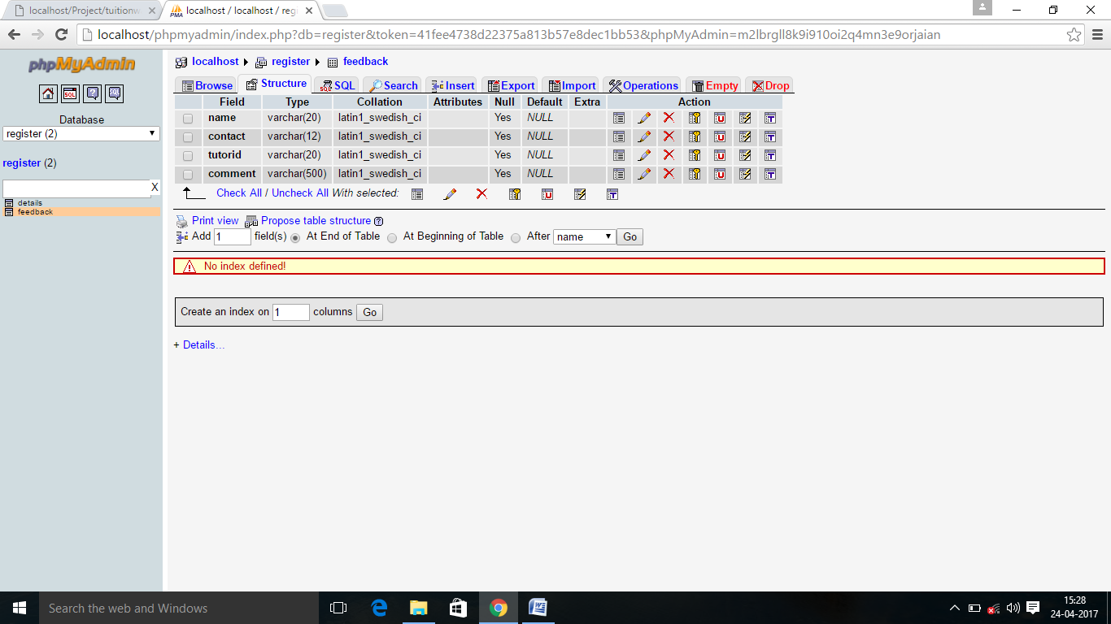

**11. SCREEN SHOTS**

* Home and User Signup page

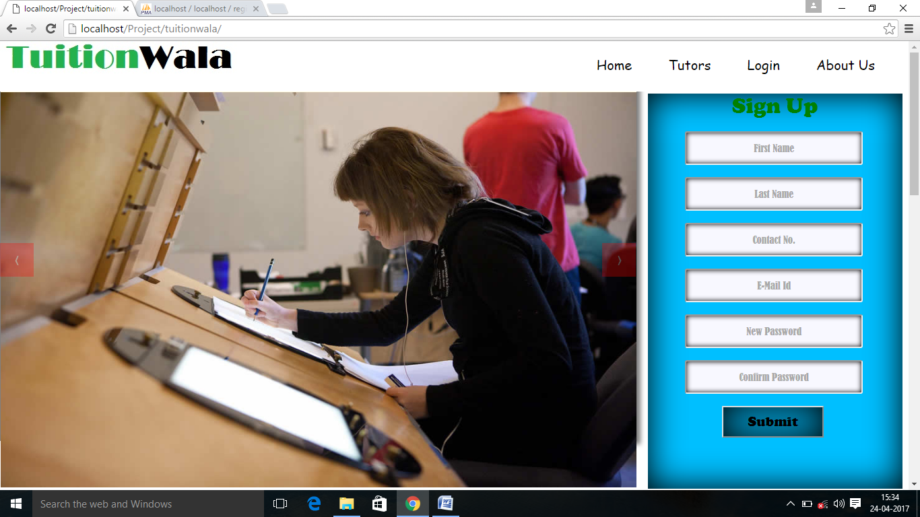

* User Registration Page

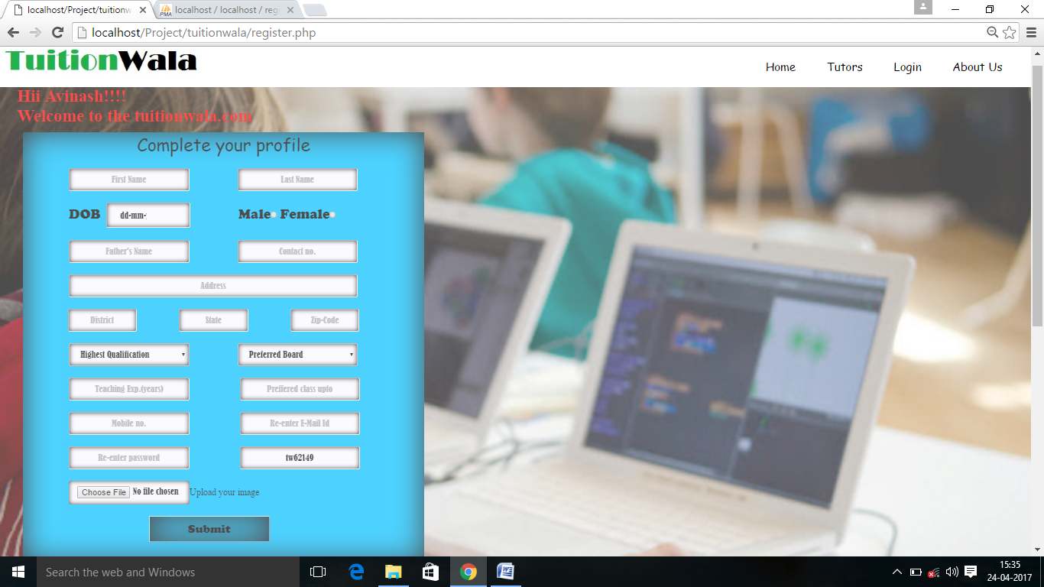

* Tuor’s List Page

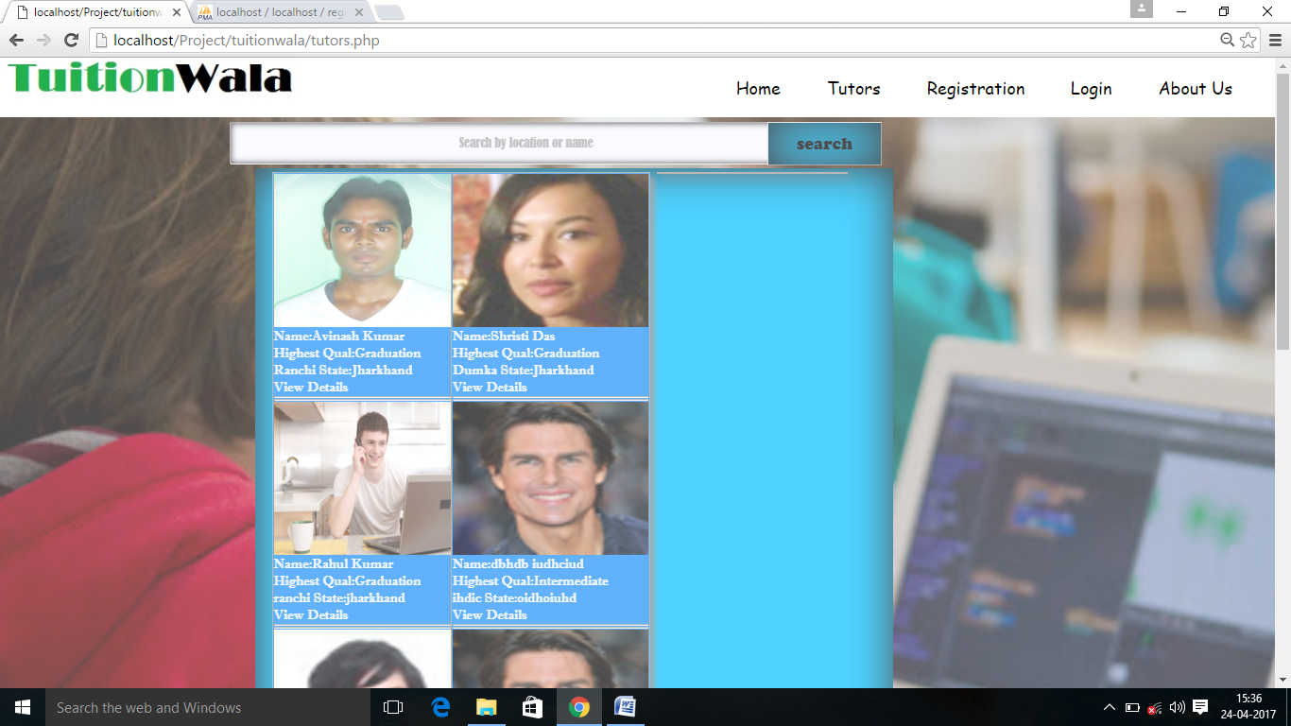

* 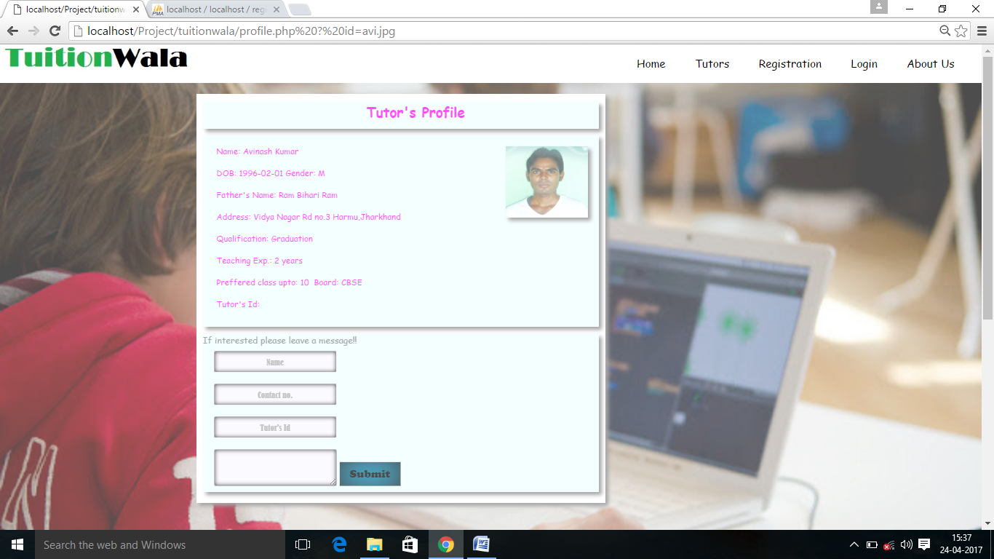Profile details of tutor

* 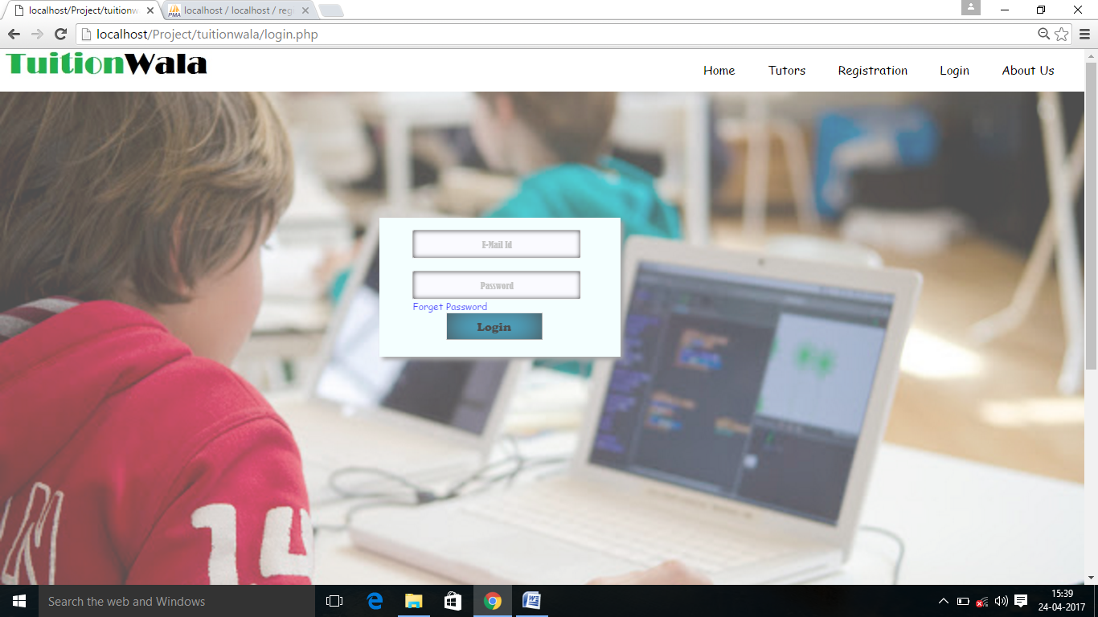Login page for tutor

* Account page

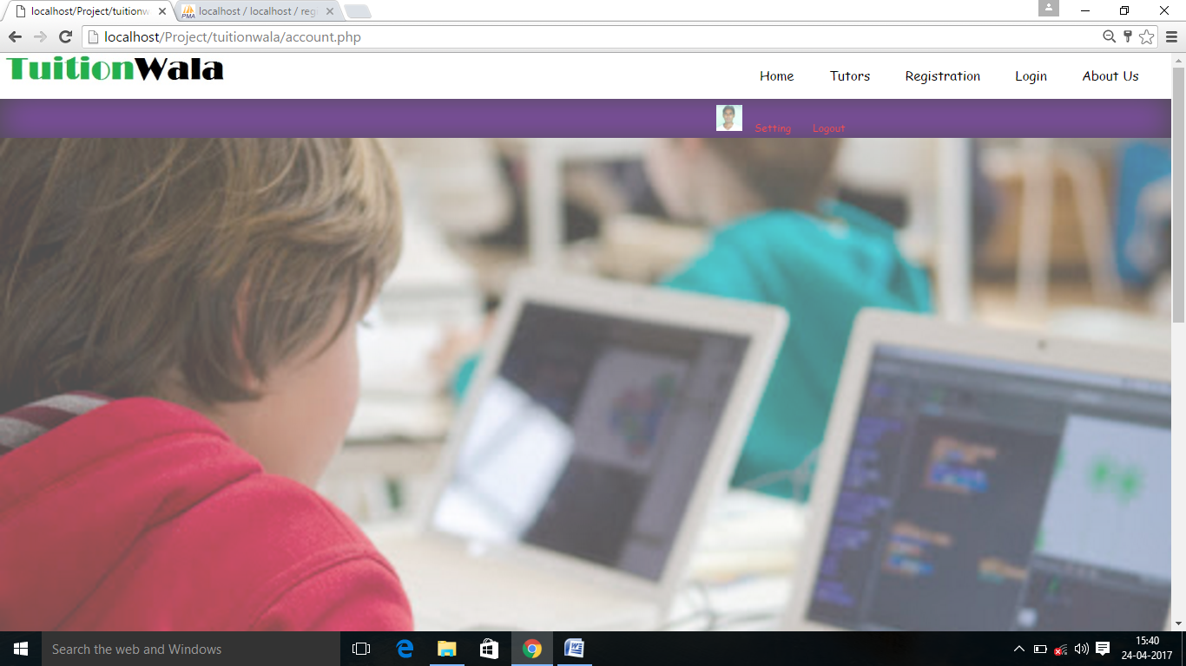

**7. CODING OF HTML**

* Home Page

<html>

<head>

<link rel="stylesheet" href="css/style.css">

<script type="text/javascript" src="js/jquery-3.1.1.min.js"></script>

<script type="text/javascript" src="js/jquery.cycle2.min.js"></script>

</head>

<body>

<script>

function valid()

{

var count=0,num,c1,c2;

if(t1.value=="")

{

alert("Fill the firstname");

/*document.getElementById("k1").innerHTML="*Fill the name";*/

return false;

}

if(t2.value=="")

{

alert("Fill the lastname");

/*document.getElementById("k2").innerHTML="*Fill the name";*/

return false;

}

num=parseInt(t3.value);

for(i=num;i>0;i=Math.floor(i/10))

count++;

if(count!=10)

{

alert("Invalid mobile no.")

/*document.getElementById("k3").innerHTML="*Invalid mobile no.";*/

return false;

}

str=t4.value;

c1=str.indexOf("@");

c2=str.indexOf(".com");

if(c1==-1||c2==-1)

{

alert("Invalid E-Mail Id");

return false;

}

if(t5.value=="")

{

alert("Password must contain alphabets,numbers,symbols");

/*document.getElementById("k2").innerHTML="*Fill the name";*/

return false;

}

if(t6.value=="")

{

alert("Password must contain Alphabet,Numbers,Symbols");

/*document.getElementById("k2").innerHTML="*Fill the name";*/

return false;

}

if(t5.value!=t6.value)

{

alert("Password is not same!!!!");

return false;

}

alert("Registration successful.Please click OK to complete your profile");

}

</script>

<nav>

<a href="index.php">Home</a>

<a href="tutors.php">Tutors</a>

<a href="login.php">Login</a>

<a href="about.php">About Us</a>

</nav>

<div class="sect sectone">

<div id="slider_image" class="cycle-slideshow"

data-cycle-x="fade"

data-cycle-speed="600"

data-cycle-timeout="3000"

data-cycle-next="#next"

data-cycle-prev="#prev"

data-cycle-manual-fx="scrollHorz"

data-cycle-manual-speed="400"

data-cycle-pager-fx="fade">

<img src="Image/slide1.jpg" alt="">

<img src="Image/slide2.jpg" alt="">

<img src="Image/slide3.jpg" alt="">

<img src="Image/slide4.jpg" alt="">

<img src="Image/slide5.jpg" alt="">

</div>

<div id="regpanel">

<h1>Sign Up</h1>

<form name="xyz" method="post" onsubmit="return valid()" action="index.php">

<?php

if(isset($_REQUEST["Submit"]))

{

include('conn.php');

$p1=$_REQUEST["t1"];

$p2=$_REQUEST["t2"];

$p3=$_REQUEST["t3"];

$p4=$_REQUEST["t4"];

$p5=$_REQUEST["t5"];

$p6=$_REQUEST["t6"];

mysql_query("Insert into signup values('$p1','$p2',$p3,'$p4','$p5','$p6')");

header( 'Location: register.php' );

}

?>

<input type="text" name="t1" id="t1" placeholder="First Name"><br><br>

<input type="text" name="t2" id="t2" placeholder="Last Name"><br><br>

<input type="text" name="t3" id="t3" placeholder="Contact No."><br><br>

<input type="text" name="t4" id="t4" placeholder="E-Mail Id"><br><br>

<input type="password" name="t5" id="t5" placeholder="New Password"><br><br>

<input type="password" name="t6" id="t6" placeholder="Confirm Password"><br><br>

<input type="submit" name="Submit" value="Submit" >

</div>

<div id="pager"></div>

<div id="next">&rang;</div>

<div id="prev">&lang;</div>

</div>

<hr>

<div class="subsection">

<h1>Now search for tuition becomes easy with TuitionWala.com</h1>

<div class="flip3d">

<div class="back"><h3><font color="beige">No need to contact any cosultancy.<br>No need to pay your half earnings to them.<br>Simply register yourself at tutionwala.com to find your tuition.</font> </h3></div>

<div class="front"><h2><font color="palegreen">Easy To Use</font></h2></div>

</div>

<div class="flip3d">

<div class="back"><h3><font color="beige">Register yourself and wait for response.<br>The parents will see your profile and calls you to hire.<br>Convince them and get your tuition.</font></h3></div>

<div class="front"><h2><font color="palegreen">Responsive</font></h2></div>

</div>

<div class="flip3d">

<div class="back"><h3><font color="beige">Our team always alerts you whenever we get any response from parents for you.<br>We will inform you about students matching your requirements through msg alerts or an e-mail.</font></h3></div>

<div class="front"><h2><font color="palegreen">Team Support</font></h2></div>

</div></div>

<hr>

<div class="sect secttwo">

<h1>Just SignUp in TuitionWala</h1>

<h1>Submit your details like qualification,teaching experience etc</h1>

<h1>Wait for few days</h1>

<h1>Start your tuition</h1>

<a href="#"><h4>Register Now>>>>>><h4></a>

<div class="bottom-slide">

<marquee behavior="alternate"> <img src="Image/btslide1.png" height="200px" width="200px">

<img src="Image/btslide2.jpg" height="200px" width="200px">

<img src="Image/btslide3.jpg" height="200px" width="200px">

<img src="Image/btslide4.png" height="200px" width="200px">

<img src="Image/btslide5.png" height="200px" width="200px">

<img src="Image/btslide6.png" height="200px" width="200px">

<img src="Image/btslide2.jpg" height="200px" width="200px">

<img src="Image/btslide3.jpg" height="200px" width="200px">

<img src="Image/btslide4.png" height="200px" width="200px">

<img src="Image/btslide5.png" height="200px" width="200px">

<img src="Image/btslide6.png" height="200px" width="200px">

</marquee>

</div>

</div>

<div class="subsection1">

<ul>

<li><font size="5px" color="Azure">Address</font></li>

<li>Address:A-15,Vidya Nagar Harmu Ranchi</li>

<li>Email:<a href="www.gmail.com">avinasheric23@gmail.com</a><br>&nbsp;&nbsp;&nbsp;&nbsp;&nbsp;&nbsp;&nbsp;&nbsp;&nbsp;&nbsp;&nbsp;&nbsp;<a href="www.gmail.com">krtechavi123@gmail.com</a></li>

<li>Website:www.tuitionwala.com</li>

<li>Give a Miss Call:9852079688</li>

</ul>

<ul>

<li><font size="5px" color="Azure">Our Company</font></li>

<li>>About Us</li>

<li>>Support</li>

<li>>Terms & Conditions</li>

<li>>Privacy Policy</li>

<li>>Copyright</li>

<li>>Clients</li>

<li>>Blog</li>

</ul>

<ul>

<li><font size="5px" color="Azure">Follow us</font></li>

<li>Facebook:@tuitionwala123</li>

<li>YouTube:Techavi</li>

<li>Twitter</li>

</ul>

</div>

<div class="foot1">&copyCopy Rights:2017&nbsp;&nbsp;All Rights Reserved&nbsp;&nbsp;<a href="tuitionwala.com">tutionwala.com</a></div>

</body>

</html>

* Registration Page

<html>

<head>

<link rel="stylesheet" href="css/regist1.css">

<script type="text/javascript" src="js/jquery-3.1.1.min.js"></script>

<script type="text/javascript" src="js/jquery.cycle2.min.js"></script>

</head>

<body>

<nav>

<a href="index.php">Home</a>

<a href="tutors.php">Tutors</a>

<a href="login.php">Login</a>

<a href="about.php">About Us</a>

</nav>

<script>

function valid()

{

var count=0,num,c1,c2;

var counts=0,numb;

if(t1.value=="")

{

alert("Fill the firstname");

/*document.getElementById("k1").innerHTML="*Fill the name";*/

return false;

}

if(t2.value=="")

{

alert("Fill the lastname");

/*document.getElementById("k2").innerHTML="*Fill the name";*/

return false;

}

if(d1.value=="")

{

alert("Your DOB is must required");

/*document.getElementById("k2").innerHTML="*Fill the name";*/

return false;

}

/*if(r1.value=="")

{

alert("Please select your gender");

return false;

}*/

if(t3.value=="")

{

alert("Fill the Father's name");

/*document.getElementById("k2").innerHTML="*Fill the name";*/

return false;

}

num=parseInt(t12.value);

for(i=num;i>0;i=Math.floor(i/10))

count++;

if(count!=10)

{

alert("Invalid mobile no.")

/*document.getElementById("k3").innerHTML="*Invalid mobile no.";*/

return false;

}

if(t4.value=="")

{

alert("Fill the address");

/*document.getElementById("k2").innerHTML="*Fill the name";*/

return false;

}

if(t5.value=="")

{

alert("Fill the district name");

/*document.getElementById("k2").innerHTML="*Fill the name";*/

return false;

}

if(t6.value=="")

{

alert("Fill the state name");

/*document.getElementById("k2").innerHTML="*Fill the name";*/

return false;

}

if(t7.value=="")

{

alert("Fill your area zip-code");

/*document.getElementById("k2").innerHTML="*Fill the name";*/

return false;

}

if(s1.value=="Highest Qualification")

{

alert("Your highest qualification");

/*document.getElementById("k2").innerHTML="*Fill the name";*/

return false;

}

else if(s1.value=="")

{

alert("Your highest qualification");

/*document.getElementById("k2").innerHTML="*Fill the name";*/

return false;

}

if(s3.value=="Preferred Board")

{

alert("Your preferred board");

/*document.getElementById("k2").innerHTML="*Fill the name";*/

return false;

}

else if(s3.value=="")

{

alert("Your preferred board");

/*document.getElementById("k2").innerHTML="*Fill the name";*/

return false;

}

if(t8.value=="")

{

alert("Your teaching experience");

/*document.getElementById("k2").innerHTML="*Fill the name";*/

return false;

}

if(t9.value=="")

{

alert("Which class you prefer to teach?");

/*document.getElementById("k2").innerHTML="*Fill the name";*/

return false;

}

numb=parseInt(t10.value);

for(i=numb;i>0;i=Math.floor(i/10))

counts++;

if(counts!=10)

{

alert("Invalid mobile no.")

/*document.getElementById("k3").innerHTML="*Invalid mobile no.";*/

return false;

}

str=t11.value;

c1=str.indexOf("@");

c2=str.indexOf(".com");

if(c1==-1||c2==-1)

{

alert("Invalid E-Mail Id");

return false;

}

if(t13.value=="")

{

alert("Please enter your password");

/*document.getElementById("k2").innerHTML="*Fill the name";*/

return false;

}

if(f.value=="")

{

alert("Please upload your passport size image");

/*document.getElementById("k2").innerHTML="*Fill the name";*/

return false;

}

}

</script>

<div class="main">

<h1><font color="red">Hii Avinash!!!!<br>Welcome to the tuitionwala.com</font></h1>

<div class="main1">

<p>Complete your profile</p>

<form name="asdad" method="post" action="register.php" onsubmit="return valid()">

<?php

if(isset($_REQUEST["Submit"]))

{

include('conn1.php');

$p1=$_REQUEST["t1"];

$p2=$_REQUEST["t2"];

$p3=$_REQUEST["d1"];

$p4=$_REQUEST["r1"];

$p6=$_REQUEST["t3"];

$p7=$_REQUEST["t12"];

$p8=$_REQUEST["t4"];

$p9=$_REQUEST["t5"];

$p10=$_REQUEST["t6"];

$p11=$_REQUEST["t7"];

$p12=$_REQUEST["s1"];

$p14=$_REQUEST["t8"];

$p15=$_REQUEST["t9"];

$p16=$_REQUEST["s3"];

$p17=$_REQUEST["t10"];

$p18=$_REQUEST["t11"];

$p13=$_REQUEST["t13"];

$p20=$_REQUEST["t14"];

$p19=$_REQUEST["f"];

mysql_query("Insert into details values('$p1','$p2','$p3','$p4','$p6','$p7','$p8','$p9','$p10','$p11','$p12','$p14','$p15','$p16','$p17','$p18','$p13','$p20','$p19')");

}

?>

<div class="f1">

<input type="text" name="t1" id="t1" placeholder="First Name">

<input type="text" name="t2" id="t2" placeholder="Last Name"><br><br>

</div>

<div class="f2">

&nbsp;&nbsp;&nbsp;&nbsp;&nbsp;&nbsp;&nbsp;&nbsp;&nbsp;&nbsp;&nbsp;&nbsp;&nbsp;&nbsp;&nbsp;&nbsp;&nbsp;&nbsp;&nbsp;&nbsp;<font size="5px" face="cooper">DOB</font><input type="date" name="d1" id="d1">

&nbsp;&nbsp;&nbsp;&nbsp;&nbsp;&nbsp;&nbsp;&nbsp;&nbsp;&nbsp;&nbsp;&nbsp;&nbsp;&nbsp;&nbsp;&nbsp;&nbsp;&nbsp;&nbsp;&nbsp;<font size="5px" face="cooper">Male</font><input type="radio" name="r1" id="r1" value="M">

<font size="5px" face="cooper">Female</font><input type="radio" name="r1" id="r1" value="F"><br><br>

</div>

<div class="f3">

<input type="text" name="t3" id="t3" placeholder="Father's Name">

<input type="text" name="t12" id="t12" placeholder="Contact no."><br><br></div>

<div class="f4"><input type="text" name="t4" id="t4" placeholder="Address"><br><br></div>

<div class="f5">&nbsp;&nbsp;<input type="text" name="t5" id="t5" placeholder="District">

<input type="text" name="t6" id="t6" placeholder="State">

<input type="text" name="t7" id="t7" placeholder="Zip-Code"><br><br></div>

<div class="f6"><select name="s1" id="s1"><option>Highest Qualification</option><option>Matriculation</option><option>Intermediate</option><option>Graduation</option><option>Post Graduation</option></select>

<select name="s3" id="s3"><option>Preferred Board</option><option>All Board</option><option>State Board</option><option>CBSE</option><option>ICSE</option></select><br><br></div>

<div class="f7"><input type="text" name="t8" id="t8" placeholder="Teaching Exp.(years)">&nbsp;&nbsp;<input type="text" name="t9" id="t9" placeholder="Preffered class upto"><br><br></div>

<div class="f9"><input type="text" name="t10" id="t10" placeholder="Mobile no.">&nbsp;&nbsp;<input type="text" name="t11" id="t11" placeholder="Re-enter E-Mail Id"><br><br></div>

<div class="f8"><input type="password" name="t13" id="t13" placeholder="Re-enter password"></div><br><div class="f12"><input type="text" name="t14" id="t14" value="<?php $c=1; echo"tw";echo$c=$c+62148; $c++; ?>" readonly><br></div>

<div class="f11"><input type="file" name="f" id="f">Upload your image</div><br>

<div class="f10"><input type="submit" value="Submit" name="Submit" id="Submit"></div>

</form>

</div>

</div>

<div class="subsection1">

<ul>

<li><font size="5px" color="Azure">Address</font></li>

<li>Address:A-15,Vidya Nagar Harmu Ranchi</li>

<li>Email:<a href="www.gmail.com">avinasheric23@gmail.com</a><br>&nbsp;&nbsp;&nbsp;&nbsp;&nbsp;&nbsp;&nbsp;&nbsp;&nbsp;&nbsp;&nbsp;&nbsp;<a href="www.gmail.com">krtechavi123@gmail.com</a></li>

<li>Website:www.tuitionwala.com</li>

<li>Give a Miss Call:9852079688</li>

</ul>

<ul>

<li><font size="5px" color="Azure">Our Company</font></li>

<li>>About Us</li>

<li>>Support</li>

<li>>Terms & Conditions</li>

<li>>Privacy Policy</li>

<li>>Copyright</li>

<li>>Clients</li>

<li>>Blog</li>

</ul>

<ul>

<li><font size="5px" color="Azure">Follow us</font></li>

<li>Facebook:@tuitionwala123</li>

<li>YouTube:Techavi</li>

<li>Twitter</li>

</ul>

</div>

<div class="foot1">&copyCopy Rights:2017&nbsp;&nbsp;All Rights Reserved&nbsp;&nbsp;<a href="tuitionwala.com">tutionwala.com</a></div>

</body>

</html>

* Tutors page

<html>

<head>

<link rel="stylesheet" href="css/tutors.css">

</head>

<body>

<nav>

<a href="index.php">Home</a>

<a href="tutors.php">Tutors</a>

<a href="login.php">Login</a>

<a href="about.php">About Us</a>

</nav>

<div class="main">

<form name="asdd" method="post" action="search.php">

<input type="text" name="t1" id="t1" placeholder="Search by location or name">

<input type="submit" name="search" value="search">

</form>

<div class="main1">

<table class="table">

<?php

include("conn1.php");

$res=mysql_query("select * from details");

$count=mysql_numrows($res);

$x=0;

$count=3;

while($x<$count)

{

$img=mysql_result($res,$x,"pic");

$name=mysql_result($res,$x,"firstname");

$lname=mysql_result($res,$x,"lastname");

$qualif=mysql_result($res,$x,"hquali");

$dist=mysql_result($res,$x,"district");

$state=mysql_result($res,$x,"state");

$x++;

?>

<tr><td><img src='<?php echo$img; ?>' height="180px" width="230px"></td></tr>

<tr><td>Name:<?php echo$name; ?>&nbsp;<?php echo$lname; ?></td></tr>

<tr><td>Highest Qual:<?php echo$qualif; ?></td></tr>

<tr><td><?php echo$dist; ?>&nbsp;State:<?php echo$state; ?></td></tr>

<tr><td><a href="profile.php ? id=<?php echo$img; ?>">View Details</a></td></tr>

<tr><td><hr></td></tr>

<tr><td><hr></td></tr>

<?php

}

?>

</table></div>

<div class="main2">

<table class="table1">

<?php

include("conn1.php");

$res=mysql_query("select * from details");

$count=mysql_numrows($res);

$x=3;

$count=6;

while($x<$count)

{

$img=mysql_result($res,$x,"pic");

$name=mysql_result($res,$x,"firstname");

$lname=mysql_result($res,$x,"lastname");

$qualif=mysql_result($res,$x,"hquali");

$dist=mysql_result($res,$x,"district");

$state=mysql_result($res,$x,"state");

$x++;

?>

<tr><td><img src='<?php echo$img; ?>' height="180px" width="230px"></td></tr>

<tr><td>Name:<?php echo$name; ?>&nbsp;<?php echo$lname; ?></td></tr>

<tr><td>Highest Qual:<?php echo$qualif; ?></td></tr>

<tr><td><?php echo$dist; ?>&nbsp;State:<?php echo$state; ?></td></tr>

<tr><td><a href="profile.php ? id=<?php echo$img; ?>">View Details</a></td></tr>

<tr><td><hr></td></tr>

<tr><td><hr></td></tr>

<?php

}

?>

</table>

</div>

<div class="main3">

<table class="table2">

<?php

include("conn1.php");

$res=mysql_query("select * from details");

$count=mysql_numrows($res);

$x=6;

while($x<$count)

{

$img=mysql_result($res,$x,"pic");

$name=mysql_result($res,$x,"firstname");

$lname=mysql_result($res,$x,"lastname");

$qualif=mysql_result($res,$x,"hquali");

$dist=mysql_result($res,$x,"district");

$state=mysql_result($res,$x,"state");

$x++;

?>

<tr><td><img src='<?php echo$img; ?>' height="180px" width="230px"></td></tr>

<tr><td>Name:<?php echo$name; ?>&nbsp;<?php echo$lname; ?></td></tr>

<tr><td>Highest Qual:<?php echo$qualif; ?></td></tr>

<tr><td><?php echo$dist; ?>&nbsp;State:<?php echo$state; ?></td></tr>

<tr><td><a href="profile.php ? id=<?php echo$img; ?>">View Details</a></td></tr>

<tr><td><hr></td></tr>

<tr><td><hr></td></tr>

<?php

}

?>

</table>

</div>

</div>

<div class="subsection1">

<ul>

<li><font size="5px" color="Azure">Address</font></li>

<li>Address:A-15,Vidya Nagar Harmu Ranchi</li>

<li>Email:<a href="www.gmail.com">avinasheric23@gmail.com</a><br>&nbsp;&nbsp;&nbsp;&nbsp;&nbsp;&nbsp;&nbsp;&nbsp;&nbsp;&nbsp;&nbsp;&nbsp;<a href="www.gmail.com">krtechavi123@gmail.com</a></li>

<li>Website:www.tuitionwala.com</li>

<li>Give a Miss Call:9852079688</li>

</ul>

<ul>

<li><font size="5px" color="Azure">Our Company</font></li>

<li>>About Us</li>

<li>>Support</li>

<li>>Terms & Conditions</li>

<li>>Privacy Policy</li>

<li>>Copyright</li>

<li>>Clients</li>

<li>>Blog</li>

</ul>

<ul>

<li><font size="5px" color="Azure">Follow us</font></li>

<li>Facebook:@tuitionwala123</li>

<li>YouTube:Techavi</li>

<li>Twitter</li>

</ul>

</div>

<div class="foot1">&copyCopy Rights:2017&nbsp;&nbsp;All Rights Reserved&nbsp;&nbsp;<a href="tuitionwala.com">tutionwala.com</a></div>

</body>

</html>

* Profile Page

<html>

<head>

<link rel="stylesheet" href="css/profile1.css">

</head>

<body>

<nav>

<a href="index.php">Home</a>

<a href="tutors.php">Tutors</a>

<a href="login.php">Login</a>

<a href="about.php">About Us</a>

</nav>

<div class="main">

<div class="main1">

<div class="main2"><h2>Tutor's Profile</h2></div>

<div class="profile">

<script>

function valid()

{

var num,count=0;

if(t1.value=="")

{

alert("Fill your name");

return false;

}

num=parseInt(t2.value);

for(i=num;i>0;i=Math.floor(i/10))

count++;

if(count!=10)

{

alert("Invalid mobile no.")

/*document.getElementById("k3").innerHTML="*Invalid mobile no.";*/

return false;

}

if(t3.value=="")

{

alert("Tutor's Id is must");

return false;

}

if(t4.value=="")

{

alert("Please insert your comment and address");

return false;

}

alert("Thanks for your comment.We will very soon response to your comment.")

}

</script>

<?php

include("conn1.php");

$p1=$_REQUEST["id"];

$res=mysql_query("select * from details where pic='$p1'");

$count=mysql_numrows($res);

$x=0;

while($x<$count)

{

$img=mysql_result($res,$x,"pic");

$name=mysql_result($res,$x,"firstname");

$lname=mysql_result($res,$x,"lastname");

$dob=mysql_result($res,$x,"dob");

$gender=mysql_result($res,$x,"gender");

$father=mysql_result($res,$x,"father");

$address=mysql_result($res,$x,"address");

$state=mysql_result($res,$x,"state");

$qualif=mysql_result($res,$x,"hquali");

$teachexp=mysql_result($res,$x,"teachexp");

$prefclass=mysql_result($res,$x,"prefclass");

$prefboard=mysql_result($res,$x,"prefboard");

$id=mysql_result($res,$x,"id");

$x++;

?>

<img src='<?php echo$img;?>'></img>

<p>Name: <?php echo$name;?>&nbsp;<?php echo$lname;?><br><br>

DOB: <?php echo$dob;?> Gender: <?php echo$gender;?><br><br>

Father's Name: <?php echo$father;?><br><br>

Address: <?php echo$address;?>,<?php echo$state;?><br><br>

Qualification: <?php echo$qualif;?><br><br>

Teaching Exp.: <?php echo$teachexp;?><br><br>

Preffered class upto: <?php echo$prefclass;?>&nbsp; Board: <?php echo$prefboard;?><br><br>

Tutor's Id: <?php echo$id;?>

</p><?php

}

?>

</div>

<div class="feedback">

<font size="3px" color="Grey" face="cursive">If interested please leave a message!!</font></br>

<form name="abcd" method="post" action="profile.php" onsubmit="return valid()">

<?php

if(isset($_REQUEST["Submit"]))

{

include('conn1.php');

$p1=$_REQUEST["t1"];

$p2=$_REQUEST["t2"];

$p3=$_REQUEST["t3"];

$p4=$_REQUEST["t4"];

mysql_query("Insert into feedback values('$p1','$p2','$p3','$p4')");

header( 'Location: tutors.php' );

}

?>

<input type="text" name="t1" id="t1" placeholder="Name"><br><br><br>

<input type="text" name="t2" id="t2" placeholder="Contact no."><br><br><br>

<input type="text" name="t3" id="t3" placeholder="Tutor's Id"><br><br><br>

<textarea name="t4" id="t4"></textarea>

<input type="submit" name="Submit" Value="Submit">

</form>

</div>

</div>

</div>

<div class="subsection1">

<ul>

<li><font size="5px" color="Azure">Address</font></li>

<li>Address:A-15,Vidya Nagar Harmu Ranchi</li>

<li>Email:<a href="www.gmail.com">avinasheric23@gmail.com</a><br>&nbsp;&nbsp;&nbsp;&nbsp;&nbsp;&nbsp;&nbsp;&nbsp;&nbsp;&nbsp;&nbsp;&nbsp;<a href="www.gmail.com">krtechavi123@gmail.com</a></li>

<li>Website:www.tuitionwala.com</li>

<li>Give a Miss Call:9852079688</li>

</ul>

<ul>

<li><font size="5px" color="Azure">Our Company</font></li>

<li>>About Us</li>

<li>>Support</li>

<li>>Terms & Conditions</li>

<li>>Privacy Policy</li>

<li>>Copyright</li>

<li>>Clients</li>

<li>>Blog</li>

</ul>

<ul>

<li><font size="5px" color="Azure">Follow us</font></li>

<li>Facebook:@tuitionwala123</li>

<li>YouTube:Techavi</li>

<li>Twitter</li>

</ul>

</div>

<div class="foot1">&copyCopy Rights:2017&nbsp;&nbsp;All Rights Reserved&nbsp;&nbsp;<a href="tuitionwala.com">tutionwala.com</a></div>

</body>

</html>

* Search

<html>

<head>

<link rel="stylesheet" href="css/search.css">

</head>

<body>

<nav>

<a href="index.php">Home</a>

<a href="tutors.php">Tutors</a>

<a href="register.php">Registration</a>

<a href="login.php">Login</a>

<a href="#">About Us</a>

</nav>

<div class="main">

<form name="asdd" method="post" action="search.php">

<input type="text" name="t1" id="t1" placeholder="Search by location">

<input type="submit" name="search" value="search">

</form>

<!--<a href="#"><font size="3px" face="cooper">1</font></a>-->

<div class="main1">

<center><table class="table">

<?php

include('conn1.php');

$p9=$_REQUEST["t1"];

$x=0;

$res=mysql_query("select * from details where district='$p9'");

$count=mysql_numrows($res);

while($x<$count)

{

$img=mysql_result($res,$x,"pic");

$name=mysql_result($res,$x,"firstname");

$lname=mysql_result($res,$x,"lastname");

$qualif=mysql_result($res,$x,"hquali");

$dist=mysql_result($res,$x,"district");

$state=mysql_result($res,$x,"state");

$x++;

?>

<tr><td><img src='<?php echo$img; ?>' height="180px" width="230px"></img><br>

Name:<?php echo$name; ?>&nbsp;&nbsp;<?php echo$lname; ?><br>

Highest Qualif.:<?php echo$qualif; ?><br>

District:<?php echo$dist; ?>&nbsp;&nbsp;State:<?php echo$state; ?><br>

<a href="profile.php ? id=<?php echo$img; ?>">View Details</a><br></td></tr>

<tr><td><hr></td></tr>

<tr><td><hr></td></tr>

<?php

}

?>

</table></center>

</div>

</div>

<div class="subsection1">

<ul>

<li><font size="5px" color="Azure">Address</font></li>

<li>Address:A-15,Vidya Nagar Harmu Ranchi</li>

<li>Email:<a href="www.gmail.com">avinasheric23@gmail.com</a><br>&nbsp;&nbsp;&nbsp;&nbsp;&nbsp;&nbsp;&nbsp;&nbsp;&nbsp;&nbsp;&nbsp;&nbsp;<a href="www.gmail.com">krtechavi123@gmail.com</a></li>

<li>Website:www.tuitionwala.com</li>

<li>Give a Miss Call:9852079688</li>

</ul>

<ul>

<li><font size="5px" color="Azure">Our Company</font></li>

<li>>About Us</li>

<li>>Support</li>

<li>>Terms & Conditions</li>

<li>>Privacy Policy</li>

<li>>Copyright</li>

<li>>Clients</li>

<li>>Blog</li>

</ul>

<ul>

<li><font size="5px" color="Azure">Follow us</font></li>

<li>Facebook:@tuitionwala123</li>

<li>YouTube:Techavi</li>

<li>Twitter</li>

</ul>

</div>

<div class="foot1">&copyCopy Rights:2017&nbsp;&nbsp;All Rights Reserved&nbsp;&nbsp;<a href="tuitionwala.com">tutionwala.com</a></div>

</body>

</html>

* User Login

<html>

<head>

<link rel="stylesheet" href="css/avi.css">

</head>

<body>

<nav>

<a href="index.php">Home</a>

<a href="tutors.php">Tutors</a>

<a href="login.php">Login</a>

<a href="about.php">About Us</a>

</nav>

<div class="main">

<div class="main1">

<script>

function check()

{

var c1,c2;

str=t1.value;

c1=str.indexOf("@");

c2=str.indexOf(".com");

if(c1==-1||c2==-1)

{

alert("Invalid E-Mail Id");

return false;

}

if(t2.value=="")

{

alert("please enter your password");

return false;

}

}

</script>

<form name="asad" method="post" action="account.php" onsubmit="return check()">

<div class="f1">

<input type="text" name="t1" id="t1" placeholder="E-Mail Id"><br></div>

<div class="f4"><input type="password" name="t2" id="t2" placeholder="Password"><br></div>

<div class="f3"><a href="pwdfor.php">Forget Password</a></div>

<div class="f2"><input type="submit" name="s1" value="Login"></div>

</form>

</div>

</div>

<div class="subsection1">

<ul>

<li><font size="5px" color="Azure">Address</font></li>

<li>Address:A-15,Vidya Nagar Harmu Ranchi</li>

<li>Email:<a href="www.gmail.com">avinasheric23@gmail.com</a><br>&nbsp;&nbsp;&nbsp;&nbsp;&nbsp;&nbsp;&nbsp;&nbsp;&nbsp;&nbsp;&nbsp;&nbsp;<a href="www.gmail.com">krtechavi123@gmail.com</a></li>

<li>Website:www.tuitionwala.com</li>

<li>Give a Miss Call:9852079688</li>

</ul>

<ul>

<li><font size="5px" color="Azure">Our Company</font></li>

<li>>About Us</li>

<li>>Support</li>

<li>>Terms & Conditions</li>

<li>>Privacy Policy</li>

<li>>Copyright</li>

<li>>Clients</li>

<li>>Blog</li>

</ul>

<ul>

<li><font size="5px" color="Azure">Follow us</font></li>

<li>Facebook:@tuitionwala123</li>

<li>YouTube:Techavi</li>

<li>Twitter</li>

</ul>

</div>

<div class="foot1">&copyCopy Rights:2017&nbsp;&nbsp;All Rights Reserved&nbsp;&nbsp;<a href="tuitionwala.com">tutionwala.com</a></div>

</body>

</html>

* Password Reset Page

<html>

<head>

<link rel="stylesheet" href="css/login.css">

</head>

<body>

<script>

function a()

{

alert(ok);

}

</script>

<nav>

<a href="index.php">Home</a>

<a href="tutors.php">Tutors</a>

<a href="login.php">Login</a>

<a href="about.php">About Us</a>

</nav>

<div class="main">

<div class="main1">

<form>

<div class="f1">

<input type="text" name="t1" id="t1" placeholder="Enter E-Mail Id"><br>

<input type="text" name="t2" id="t2" placeholder="Enter 4-digit code"><br><br></div>

<div class="f2"><input type="submit" name="s1" value="Verify" onclick=a()></div>

</form>

</div>

</div>

<div class="subsection1">

<ul>

<li><font size="5px" color="Azure">Address</font></li>

<li>Address:A-15,Vidya Nagar Harmu Ranchi</li>

<li>Email:<a href="www.gmail.com">avinasheric23@gmail.com</a><br>&nbsp;&nbsp;&nbsp;&nbsp;&nbsp;&nbsp;&nbsp;&nbsp;&nbsp;&nbsp;&nbsp;&nbsp;<a href="www.gmail.com">krtechavi123@gmail.com</a></li>

<li>Website:www.tuitionwala.com</li>

<li>Give a Miss Call:9852079688</li>

</ul>

<ul>

<li><font size="5px" color="Azure">Our Company</font></li>

<li>>About Us</li>

<li>>Support</li>

<li>>Terms & Conditions</li>

<li>>Privacy Policy</li>

<li>>Copyright</li>

<li>>Clients</li>

<li>>Blog</li>

</ul>

<ul>

<li><font size="5px" color="Azure">Follow us</font></li>

<li>Facebook:@tuitionwala123</li>

<li>YouTube:Techavi</li>

<li>Twitter</li>

</ul>

</div>

<div class="foot1">&copyCopy Rights:2017&nbsp;&nbsp;All Rights Reserved&nbsp;&nbsp;<a href="tuitionwala.com">tutionwala.com</a></div>

</body>

</html>

* About Us

<html>

<head>

<link rel="stylesheet" href="css/about.css">

<script type="text/javascript" src="js/jquery-3.1.1.min.js"></script>

<script type="text/javascript" src="js/jquery.cycle2.min.js"></script>

</head>

<body>

<nav>

<a href="index.php">Home</a>

<a href="tutors.php">Tutors</a>

<a href="login.php">Login</a>

<a href="about.php">About Us</a>

</nav>

<div class="main">

</div>

<div class="subsection1">

<ul>

<li><font size="5px" color="Azure">Address</font></li>

<li>Address:A-15,Vidya Nagar Harmu Ranchi</li>

<li>Email:<a href="www.gmail.com">avinasheric23@gmail.com</a><br>&nbsp;&nbsp;&nbsp;&nbsp;&nbsp;&nbsp;&nbsp;&nbsp;&nbsp;&nbsp;&nbsp;&nbsp;<a href="www.gmail.com">krtechavi123@gmail.com</a></li>

<li>Website:www.tuitionwala.com</li>

<li>Give a Miss Call:9852079688</li>

</ul>

<ul>

<li><font size="5px" color="Azure">Our Company</font></li>

<li>>About Us</li>

<li>>Support</li>

<li>>Terms & Conditions</li>

<li>>Privacy Policy</li>

<li>>Copyright</li>

<li>>Clients</li>

<li>>Blog</li>

</ul>

<ul>

<li><font size="5px" color="Azure">Follow us</font></li>

<li>Facebook:@tuitionwala123</li>

<li>YouTube:Techavi</li>

<li>Twitter</li>

</ul>

</div>

<div class="foot1">&copyCopy Rights:2017&nbsp;&nbsp;All Rights Reserved&nbsp;&nbsp;<a href="tuitionwala.com">tutionwala.com</a></div>

</body>

</html>

**CODING OF CSS**

* For home page

*{margin:0px; padding:0px;}

html,body{

height:100%;

}

h1,h2,h3,h4,h5,h6,p{margin-bottom:20px;}

nav{

position:fixed;

width:100%;

height:75px;

background-color:white;

z-index:99;

text-align:right;

background-image: url("../Image/avi123.jpg");

background-repeat:no-repeat;

}

nav a{

text-decoration:none;

color:black;

margin-right:50px;

line-height:70px;

font-family:cursive;

font-size:20px;

}

nav a:hover{color:blue;}

.sect{

height:100%;

background-size:cover;

background-repeat:no-repeat;

background-attachment:fixed;

}

.subsection{

height:50%;

background-color:cyan;

box-shadow:inset 0 0 40px black;

}

.subsection1{

height:40%;

background-color:dimgray;

}

.sectone{

background-color:white;

}

.secttwo{

background-image: url("../Image/slide3.jpg");

}

#slider_image

{

top:5px;

height:88%;

width:70%;

border:1px solid grey;

background-color:cornsilk;

box-shadow: 5px 5px 10px grey;

z-index:0;

}

#slider_image img

{

image-attachment:fixed;

position:relative;

margin-top:70px;

height:100%;

width:100%;

z-index:0;

top:5px;

}

#container

{

width:100%;

height:100%;

overflow:hidden;

background: #ffooff;

z-index:0;

top:5px;

}

#prev

{

left:0;

top:45%;

width:50px;height:50px;

text-align:center;

line-height:50px;

background-color:red;

color:white;

position:absolute;

z-index:0;

cursor:pointer;

opacity:.3;

}

#next

{

top:45%;

width:50px;height:50px;

text-align:center;

line-height:50px;

background-color:red;

color:white;

position:absolute;

z-index:0;

cursor:pointer;

right:30%;

opacity:.3;

}

#next:hover{

opacity:1;

}

#prev:hover{

opacity:1;

}

#regpanel{

position:absolute;

right:125px;

height:88%;

width:28%;

bottom:2px;

left:962px;

background-color:deepskyblue;

box-shadow:inset 0 0 80px black;

}

#pager img{

margin:10px 5px;

opacity:0.3;

transition:all .3s ease-in-out 0s;

}

#pager img:hover{

opacity:1;

transform:scale(1.05);

z-index:100;

}

h1{

text-align:center;

color:green;

font-family:cooper;

}

h2{

text-align:center;

margin-top:80px;

}

h3{

text-align:center;

font-family:cooper;

}

a{

text-decoration:none;

}

h4{

font-size:30px;

font-family:bernard mt;

text-align:center;

}

input[type=text]{

width:70%;

padding:14px 20px;

box-sizing:border-box;

margin-left:55px;

box-shadow:5px light white;

border-radius:3px;

background-color:ghostwhite;

font-size:15px;

font-family:Bernard MT;

text-align:center;

box-shadow:inset 0 0 10px black;

}

input[type=submit]{

width:40%;

padding:10px 15px;

margin-left:110px;

font-size:20px;

font-family:cooper;

background-color:deepskyblue;

box-shadow:inset 0 0 80px black;

}

input[type=password]{

width:70%;

padding:14px 20px;

box-sizing:border-box;

margin-left:55px;

box-shadow:5px light white;

border-radius:3px;

background-color:ghostwhite;

font-size:15px;

font-family:Bernard MT;

text-align:center;

box-shadow:inset 0 0 10px black;

}

p{margin-left:20px;}

#infoa{

position:absolute;

width:20%;

height:20%;

}

.flip3d{

width:250px;height:200px;margin-left:140px;float:left;

}

.flip3d>.front{

position:absolute;

transform:perspective(600px) rotatey(0deg);

background:dodgerblue;width:240px;height:200px;border-radius:7px;

backface-visibility:hidden;

transition:transform .5s linear 0s;

font-family:cooper;

box-shadow:inset 0 0 80px black;

}

.flip3d>.back{

position:absolute;

transform:perspective(600px) rotatey(180deg);

background:cornflowerblue;width:240px;height:200px;border-radius:7px;

backface-visibility:hidden;

transition:transform .5s linear 0s;

box-shadow:inset 0 0 80px black;

}

.flip3d:hover>.front{

transform:perspective(600px) rotatey(-180deg);

}

.flip3d:hover>.back{

transform:perspective(600px) rotatey(0deg);

}

.bottom-slide{

position:absolute;

width:90%;

height:250px;

background-color:azure;

padding:20px;

margin:50px;margin-top:40px;

z-index:0;

box-shadow:inset 0 0 10px black;

}

.subsection1 ul{

margin:30px;margin-left:50px;float:left;

text-decoration:none;

}

.subsection1 ul li{

font-family:Baskerville Old Face;

color:lightblack;

text-decoration:none;

}

.subsection1 ul li:hover{color:cyan;}

.foot1{

width:100%;

height:50px;

background-color:darkslategrey;

text-align:center;

}

* For all other pages

*{margin:0px; padding:0px;}

html,body{

}

h1,h2,h3,h4,h5,h6,p{margin-bottom:20px;}

nav{

position:fixed;

width:100%;

height:70px;

background-color:white;

z-index:99;

text-align:right;

background-image: url("../Image/avi123.jpg");

background-repeat:no-repeat;

}

nav a{

text-decoration:none;

color:black;

margin-right:50px;

line-height:70px;

font-family:cursive;

font-size:20px;

}

nav a:hover{color:blue;}

.main{

height:140%;

width:100%;

background-image:url("../Image/slide3.jpg");

background-repeat:no-repeat;

background-size:cover;

opacity:.7;

z-index:0;

}

.main1{

margin:40px;padding:0px;

margin-top:170px;

background-color:azure;

height:750px;

width:700px;

position:absolute;

background-color:deepskyblue;

box-shadow:inset 0 0 80px black;

}

h1{

font-size:30px;

position:absolute;

padding:opx;

padding-top:60px;

margin:30px;

}

p{

text-align:center;

font-size:30px;

font-family:cursive;

}

.f1 input[type=text]{

width:30%;

padding:10px 15px;

box-sizing:border-box;

margin-left:80px;

box-shadow:5px light white;

border-radius:3px;

background-color:ghostwhite;

font-size:15px;

font-family:Bernard MT;

text-align:center;

box-shadow:inset 0 0 10px black;

}

.f2 input[type=date]{

width:21%;

padding:10px 20px;

box-sizing:border-box;

margin-left:10px;

box-shadow:5px light white;

border-radius:3px;

background-color:ghostwhite;

font-size:15px;

font-family:Bernard MT;

text-align:center;

box-shadow:inset 0 0 10px black;

}

.f3 input[type=text]{

width:30%;

padding:10px 15px;

box-sizing:border-box;

margin-left:80px;

box-shadow:5px light white;

border-radius:3px;

background-color:ghostwhite;

font-size:15px;

font-family:Bernard MT;

text-align:center;

box-shadow:inset 0 0 10px black;

}

.f4 input[type=text]{

width:72%;

padding:10px 15px;

box-sizing:border-box;

margin-left:80px;

box-shadow:5px light white;

border-radius:3px;

background-color:ghostwhite;

font-size:15px;

font-family:Bernard MT;

text-align:center;

box-shadow:inset 0 0 10px black;

}

.f5 input[type=text]{

width:17.2%;

padding:10px 10px;

box-sizing:border-box;

margin-left:70px;

box-shadow:5px light white;

border-radius:3px;

background-color:ghostwhite;

font-size:15px;

font-family:Bernard MT;

text-align:center;

box-shadow:inset 0 0 10px black;

}

.f6 select{

width:30%;

padding:10px 15px;

box-sizing:border-box;

margin-left:80px;

box-shadow:5px light white;

border-radius:3px;

background-color:ghostwhite;

font-size:15px;

font-family:Bernard MT;

text-align:center;

box-shadow:inset 0 0 10px black;

}

.f7 input[type=text]{

width:30%;

padding:10px 15px;

box-sizing:border-box;

margin-left:80px;

box-shadow:5px light white;

border-radius:3px;

background-color:ghostwhite;

font-size:15px;

font-family:Bernard MT;

text-align:center;

box-shadow:inset 0 0 10px black;

}

.f9 input[type=text]{

width:30%;

padding:10px 15px;

box-sizing:border-box;

margin-left:80px;

box-shadow:5px light white;

border-radius:3px;

background-color:ghostwhite;

font-size:15px;

font-family:Bernard MT;

text-align:center;

box-shadow:inset 0 0 10px black;

}

.f10 input[type=submit]{

width:30%;

padding:10px 15px;

margin-left:220px;

font-size:20px;

font-family:cooper;

background-color:deepskyblue;

box-shadow:inset 0 0 80px black;

}

.f11 input[type=file]{

width:30%;

padding:10px 15px;

box-sizing:border-box;

margin:0px;

margin-left:80px;

box-shadow:5px light white;

border-radius:3px;

background-color:ghostwhite;

font-size:15px;

font-family:Bernard MT;

text-align:center;

box-shadow:inset 0 0 10px black;

}

.f8 input[type=password]

{

width:30%;

padding:10px 15px;

box-sizing:border-box;

margin:0px;

margin-left:80px;

box-shadow:5px light white;

border-radius:3px;

background-color:ghostwhite;

font-size:15px;

font-family:Bernard MT;

text-align:center;

box-shadow:inset 0 0 10px black;

}

.f12 input[type=text]

{

width:30%;

padding:10px 15px;

box-sizing:border-box;

margin:0px;

margin-top:-60px;

margin-left:378px;

box-shadow:5px light white;

border-radius:3px;

background-color:ghostwhite;

font-size:15px;

font-family:Bernard MT;

text-align:center;

box-shadow:inset 0 0 10px black;

}

.subsection1{

height:40%;

background-color:dimgray;

}

.subsection1 ul{

margin:30px;margin-left:50px;float:left;

text-decoration:none;

}

.subsection1 ul li{

font-family:Baskerville Old Face;

color:lightblack;

text-decoration:none;

}

.subsection1 ul li:hover{color:cyan;}

.foot1{

width:100%;

height:50px;

background-color:darkslategrey;

text-align:center;

}

**Limitation**

Limitations of project

There are few limitations of this project.This may be arise due to the awareness among the people about this website.Some limitations are:--

* In beginning the number of users will be less due to less awareness about this website.
* User(Parents) are not able to contact any tutor directly.
* User(Tutor) are also not able to contact any parents for tuition.

Solutions for limitations

For broad mass coverage we take help of advertisement through social websites like facebook,Whatsapp and twitter.We will also use posters for broad mass coverage.

Parents and tutors are not able to contact with each other due to security reasons.It may be possible that personal details should be used for criminal activities.

Scope of project

Our project has big scope to do.In future we will add some new features like study material(in pdf formate) for all classes of all subjects.Along with this we also add videos related to many topics of science,maths and computer.Our team is working on it and very soon it will be added to our website.



The conclusion of “Tuitionwala” is to construct such software which will provide information about

Tuition to the tutor and about the tutor to the parents.Towards the end of the project, I would like to say that the target, which was initially set up, was achieved to a good extent. The project made me realize the significance of developing software for client, where the sole aim is to learn.

During the development of project, the real importance for following all principle of system analysis and design dawned on me. I felt the necessity of going through the several stages.

As we done the initial investigation, now we can say that this application possible to create. But as project will progress there may some change in functionality of the project*.*

Following books are referred for developing this project:

**Bibliography**

**1.**“JAVA SWING COMPLETE REFERENCE”, MCGRAW-HILL EBOOKS

**BY HERBERT SCHILDT**

**2.**“SOFTWARE ENGINEERING”, SIXTH EDITION, TATA MC GRAW HILL

**BY ROGER S. PRESSMAN**

**3.**“DATABASE SYSTEM CONCEPTS”, FIFTH EDITION, TATA MC GRAW HILL

**BY HENRY F. KORTH**

**4.**SYSTEM ANALYSIS AND DESIGN

**BY ALIAS M. AWAD**

**Website visited:**

1. [www.msdn.microsoft.com](http://www.msdn.microsoft.com)
2. [www.projectcode.com](http://www.projectcode.com)
3. www.plus2net.com/sql_tutorial
4. www.W3Schools.com for CSS Tutorials